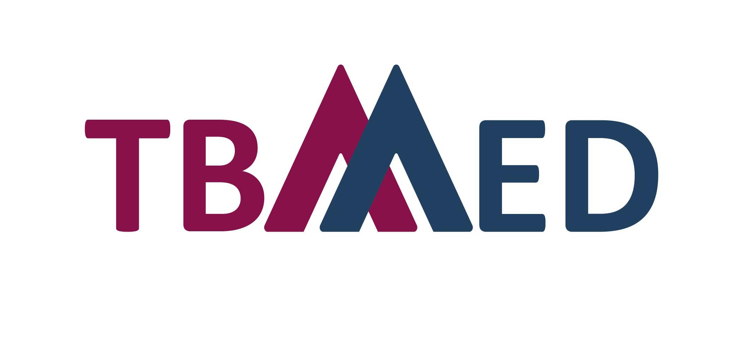

COVID-19 Call

Table of Contents
A. Applicant Information 3
Product FEATURES 4
Product INFORMATION 5
Product Description and Design (Maximum one A4 page) 5
Device Composition (Maximum one A4 page) 5
Safety and Efficacy of the product 6
Clinical Assessment (if applicable) 6
Risk management 6
Regulatory and licensing status 7
CE Marking Status (if applicable) 7
FDA Marking Status (if applicable) 7
Other Regulatory Bodies (if applicable) 7
CERTIFICATES (PRODUCT and/or company) 8
Inspections/Authorizations/Certifications/Quality Controls 8
B. Project Outline 9
State of the art 9
Technological insight 9
Expertise and resources 9
Market scenario 9
C. Authorization 10
D. Checklist of Attachments 11

Application form

Instructions:
Fill out the information that is applicable to your product, company and knowledge. Each applicant may only fill out and submit one application form.

Complete the fields in this questionnaire as applicable.
- Tick or place an X in any of the boxes that are true/applicable.
- Add rows to tables to include requested information. Alternatively, you may attach information in a separate sheet using the same format requested.
- In some cases it may be required to duplicate rows, copy the section and paste as needed.
- Update the table of contents when completed.

SUBMISSION QUESTIONNAIRE

Applicant Information
The information in this questionnaire will be shared with the members of the Selection Board for the purpose of assessing the application. You will be asked to confirm that you are okay with this at the end of the application form under “AUTHORIZATION”.

Questionnaire Submission Date (DD/MM/YYYY)
Company Name
Physical address
Postal address
Country
Telephone number
Fax
Website
Email
Type of service required  (according to the services offered) *Please review the call for more details about the support that each service offers. |  | Webinar/s education addressing the perspective of the HTA with regard to medical devices.  Early dialogues between the Basque HTA office and companies that develop COVID-19 related medical devices.  Expert advice for regional (Basque Country) and/or multinational, clinical trials on COVID-19.
Type of innovation related to COVID-19 |  | Medical device  Medical device- Software |  | Medical device- In-vitro Diagnostics
Typology / Clasification area |  | Biotechnology  Innovation assistance  ICT Health (Information and Communication Technologies) |  | Material and device  Image  Other
Impact |  | Society  Patients  Professionals  Health System sustainability |  | Image and/or prestige  Economic return for the system  Business sector
Provide contact information for each of the following:
 | Queries with regard to the application form (such as Principal Investigator) |  | Technical Specifications and Quality Assurance |  | General Inquiries
Name:
Telephone:
Cell phone:
Email:

Product FEATURES
Brand name (if any)
Website (if any)
Generic name of the product (if any)
In case of medical device, please add the EU classification | Class I Class I (Special function)  Class IIa Class IIb  Class III Not assessed yet
State of the development process (approximate TRL - Technology Readiness Level) More details are available here. | 1-3 4-6 7-9
Intended Use (300 characteres) | State the intended use of the device and/or provide a general description of the disease or condition that the device will diagnose, treat, prevent, cure or mitigate.
Target Population (300 characteres) | Describe the target patient population for which the device is intended. Specify if the device is for pediatric use.
 | Pediatric use | Not for pediatric use
Time to be introduced in the market | ≥ 4 years 1-3 years < 1 year Adaptive pathway
Competitors | Similar products/technologies/services are close to the market.  Similar products/technologies/services are far from entering the market.  Similar products/technologies/services have not been identified yet.
Feasibility of the project | The company has not developed a business plan yet.  The company has developed a business plan.  The company developed a business plan and also has a financial plan.
Use | Identify if the device is intended for single use or is reusable
 | Single Use Reusable

Product INFORMATION

Product Description and Design (Maximum one A4 page)
Attach copies of the design drawings, diagrams, photos, if applicable.
Provide a general description of design, characteristics and performance of the medical device that you have designed.

Device Composition (Maximum one A4 page)
Provide a summary of the composition of the device, including at minimum, the material specification and/or chemical composition of the materials that have direct or indirect contact with the user/patient.
Indication of biological material or derivate used in the medical device.
Biological material or derivate is used in the medical device. (If yes, specify origin (human, animal, recombinant or fermentation products or any other biological material; source (blood, bone, heart, any other tissue or cells) and the intended reason for its presence and if applicable, its primary mode of action.

Not applicable

Safety and Efficacy of the product
Tick or place an X here if there is no information available

Clinical Assessment (if applicable)
Provide a summary of the clinical evaluation of the product, if applicable.
Not applicable

Risk management
Attach a copy of the results of risk management, per product medical device, if applicable.
Provide a summary of the risks identified during the risk analysis process and how these risks have been controlled to an acceptable level. The results of the risk analysis should provide a conclusion with evidence that remaining risks are acceptable when compared to their benefits. When a standard is followed in the risk assessment, describe the standard.
Not applicable

Regulatory and licensing status

CE Marking Status (if applicable)
Provide a copy of the relevant CE Mark certificate for each applicable variant, if applicable.
Product is CE Marked
Product is not CE Marked
Product submitted for CE Mark evaluation, but is still to be approved.
Date of Submission (DD/MM/YYYY):
Comments:

FDA Marking Status (if applicable)
Provide a copy of the relevant FDA Mark certificate for each applicable variant, if applicable.
Product is approved by the US FDA: (specify authorization number)
PMA#
510K#
Other (Specify):

Product submitted for US FDA evaluation. Waiting for registration approval.
Date of Submission (DD/MM/YYYY):
Comments:

Other Regulatory Bodies (if applicable)
Provide a copy of the relevant Regulatory certificate, if applicable.
Comments:

Not applicable

CERTIFICATES (PRODUCT and/or company)
Tick or place an X here if there is no information available

Inspections/Authorizations/Certifications/Quality Controls
Add rows to the table if you need to include more information.
Type of document (Inspections/ Authorizations/ Certifications/ Quality Controls) | Authority | Certificate No. | Date Issued  (DD/MM/YYYY) | Valid until  (DD/MM/YYYY)

SPECIFIC DETAILS OF THE PROJECT

Project Outline

State of the art
Describe scientific and methodology features that justify the development of the product.
How will the device help in the fight against COVID-19?

Technological insight
Technological Development Envisaged (approximately one A4 page)
Describe the state-of-the-art of the technology and the technological developments envisaged.
Describe the needs identified to progress in the development of the medical device.
Describe the concrete results expected at the end of the project (design of the Clinical Proof of Concept or Clinical Investigation, process, etc.)

Expertise and resources
Approximately one A4 page
Describe your expertise and core business.
What is the total number of Full-Time Equivalents working on R&D (figures).
Describe your managerial expertise with regard to the market addressed.
Does the company have enough resources to complete the innovation cycle of the medical device development and achieve bringing it to the market (Yes/No). Please justify.

Market scenario
Market Application and Exploitation (approximately one A4 page)
What is the market envisaged (description)?
What is the estimated market size and expected market share?
Describe the position of the partners in the market(s)?
What is the status of the competition in the market(s)?
What are the revenues foreseen at the end of the first year?

Authorization

Authorization for sharing information
I, the undersigned [ENTER FULL NAME], CERTIFY that the information stated above is true, correct and complete to the best of my knowledge. Likewise, I confirm that the company has no objection to the information contained herein being shared with the Selection Board.

Name |  | Signature |  | Date (DD/MM/YYYY)
Full title/Position |  | Company name

Checklist of Attachments

Product Information
Copy of design drawings, diagrams, photos
Flow diagram and brief narrative describing the manufacturing and control process of this product with relevant parameters.

Safety and Efficacy and/or Therapeutic Equivalence (if any)
Clinical Evaluation Report

Risk Management (if any)
Copy of results of risk management, per medical device

Regulatory and Licensing Status (if any)
CE mark Certificate
FDA mark Certificate
Other regulatory bodies

Certificates (if any)
Recent/valid system certificates (ISO 9001, ISO 13485, other)

Authorization
Authorization to share information signed

This information is optional, you are not obliged to provide the information requested.

